BULLETIN BOARD:
Today:

10:00 am Sabbath School

11:15 am Worship Service

Please stay and join us for potluck
and
Bible prophecy study presented by Head Elder 2:30pm (after potluck)
in the fellowship hall

4:46 pm Sunset

Sunday:

9:00 am Crossroads Radio Ministry Program
KAHI AM 950 or streaming live: www.kahi.com

Thursday:

noon Information for the bulletin to to Renee’

Friday:

4:50 pm Sunset

Next Board meeting 1/27, 10:30 am

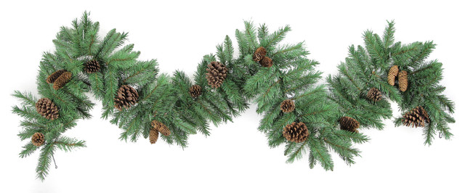

Shingle Springs SDA Church 530-677-2764
3149 North Shingle Rd, Shingle Springs, CA 95682
www.facebook.com/ShingleSpringsSDA
www.shinglesprings.adventistfaith.org
SHINGLE SPRINGS SDA CHURCH
December 22, 2018

CHURCH AT STUDY 9:45-10:55 A.M.
WELCOME
SONGS OF PRAISE
PRAYER & LESSON STUDY |  | Audrey Greenlaw
WORSHIP SERVICE 11:15 A.M. - 12:45 P.M.
Elder of the Day is Marcol Greenlaw

WELCOME/ANNOUNCEMENT  HEALTH NUGGET |  | Dr. Ben Ling
OPENING PRAYER |  | Marcol Greenlaw
PRAISE IN SONG Angels We Have Heard on High Hymn 142

OFFERING Conference Advance

Special Music Lincoln and Runon Munson
PRAYER OF INTERCESSION
SCRIPTURE Luke 2:8-14
SERMON The Marvelous Work of Angels |  | Marcol Greenlaw
CLOSING SONG It Came Upon the Midnight Clear Hymn 130
CLOSING PRAYER |  | Marcol Greenlaw
DISMISSAL

Please stay and join us for potluck

Pastor: Elder Jovan Ilijev
Elder: Marcol Greenlaw (& Treasurer)
Head Deacon: Charles Kelley
Health Director: Audrey Greenlaw

Today’s greeter is Karen

SHINGLE SPRINGS SDA CHURCH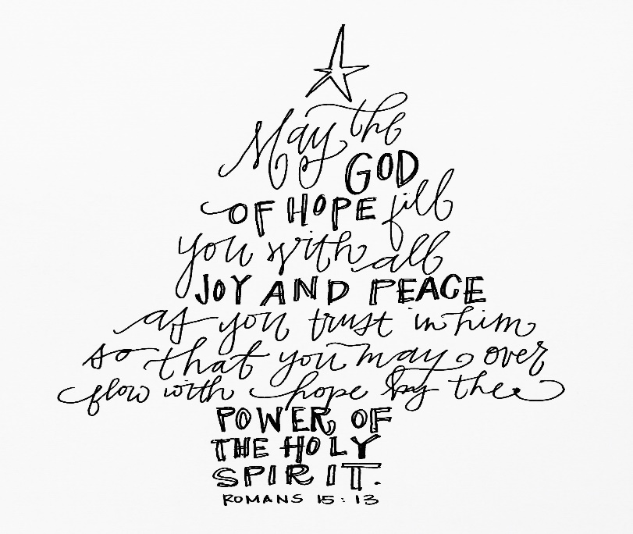
Letters of inquiry have come to us asking, Shall we
have a Christmas tree? Will it not be like the world?
We answer, You can make it like the world if you
Have a disposition to do so, or you can make it as
unlike the world as possible. There is no particular
sin in selecting a fragrant evergreen and placing it
in our churches, but the sin lies in the motive which
prompts to action and the use which is made of the
gifts placed upon the tree.
{AH 482.1} E.G.White

This year as a church we plan to contribute toward disaster relief
for survivors of the Camp/Paradise Fire through the
Northern California Conference.

If you would like to give towards this worthy
endeavor, please fill out a contribution envelope
and label it Camp Fire, then hang a tag on the Giving Tree.

